Multi-Class Classification and Detection of
Knee Osteoarthritis from X-Rays
A Project Report
Submitted by
C RISHI VARDHAN REDDY (CB.EN.U4ECE21008)
D MOHAMMAD SHAAHID (CB.EN.U4ECE21011)
DULAM SANTHOSH (CB.EN.U4ECE21012)
NUKALA SUMANTH (CB.EN.U4ECE21033)

in partial fulfillment of the requirements for the award of
the degree of
Bachelor of Technology
in
Electronics & Communication Engineering
under the supervision of
Dr. Devi Vijayan
Department of Electronics and Communication Engineering,
Amrita School of Engineering,
Amrita Vishwa Vidyapeetham,
Coimbatore – 641112

November 2024

Dept of Elec. & Communication Engineering,
Amrita School of Engineering,
Amrita Vishwa Vidyapeetham,
Coimbatore – 641112

Certificate

This is to certify that this project titled “Multi-Class Classification and Detection of Knee Osteoarthritis from X-Rays” submitted in partial fulfillment of the requirements for the award of the degree of Bachelor of Technology in Electronics & Communication Engineering, by Mr. C Rishi Vardhan Reddy, Mr. D Mohammad Shaahid, Mr. Dulam Santhosh, Mr. Nukala Sumanth is a bonafide record of work carried out by them, under my supervision and that it has not been submitted, to the best of my knowledge, in part or in full, for the award of any other degree or diploma.

Dr. Devi Vijayan
(Advisor)
Department of Electronics and Communication Engineering,
Amrita School of Engg.,
Coimbatore

Date:
This report was evaluated by us on -----------------------------------.

Internal Examiner External Examiner

Declaration

We do hereby declare that this project titled “Multi-Class Classification and Detection of Knee Osteoarthritis from X-Rays”, submitted in partial fulfillment of the requirements for the award of the degree of Bachelor of Technology in Electronics & Communication Engineering, is a true record of work carried out by us, under the supervision of Dr. Devi Vijayan and that all information contained herein, which do not arise directly from our work, have been properly acknowledged and cited, using acceptable international standards. Further, we declare that the contents of this project have not been submitted, in part or in full, for the award of any other degree or diploma.

Coimbatore – 641112 C RISHI VARDHAN REDDY
Date: D MOHAMMAD SHAAHID
DULAM SANTHOSH
NUKALA SUMANTH

Abstract
Osteoarthritis of the knee happens when cartilage in your knee joint breaks down. When this happens, the bones in your knee joint rub together, causing friction that makes your knees hurt, become stiff or swell. Osteoarthritis in the knee can’t be cured. So, Early detection of KOA will help patients to get treatments that can relieve symptoms and slow their condition’s progress. While CT scans and MRIs offer superior diagnostic detail for knee osteoarthritis, X-rays remain the most cost-effective option, making improvements in their accuracy highly beneficial. The Kellgren-Lawrence (KL) grading system grades knee osteoarthritis severity based on X-ray features, like joint space narrowing and osteophyte formation, categorizing OA into five grades.
The proposed work aims in implementing a deep learning-based framework to automatically assess the Knee OA severity in terms of Kellgren and Lawrence grade classification from X-rays using ResNet for feature extraction and SVM for Classification.
Convolutional Neural Networks (CNNs) excel at feature extraction for image classification due to their hierarchical learning of spatial features. ResNet, with its residual connections, overcomes the vanishing gradient problem, making it an optimal choice for deeper networks. Implementing CBAM enhances features, and classifying images into five distinct classes using SVM ensures precise and accurate results. The work will be evaluated with the performance metrics, namely accuracy, precision, recall and F1 score. The X-ray image dataset is taken from the Osteoarthritis Initiative (OAI) and consists of 8,260 images classified into 5 distinct classes.
Table of Contents

List of Abbreviations i
List of Symbols ii
List of Tables iii
List of Figures iv
1. Introduction 1
1.1 Background 1
1.2 Motivation 2
1.3 Overview of the report 3
2. Related Work 4
2.1 Literature Survey 4
2.2 State-of-the-art-model 6
2.2.1 VGG16 6
2.2.2 ResNet50 8
2.2.3 EfficientNet 9
3. Methodology 11
3.1 Data Preparation 11
3.2 Proposed Model 11
3.3 Data Preprocessing 13
3.3.1 Quantum Noise Reduction 13
3.3.2 Histogram Equalization 13
3.3.3 Unsharp Masking 13
3.4 Data Augmentation 14
3.5 Software 14
3.5.1 Visual Studio Code 14
3.5.2 Jupyter Notebook 15
4. Results and Discussion 17
4.1 Data Set 17
4.2 Evaluating State-of-the-art-model 17
5. Conclusion 21

References 22

List of Abbreviations

CAD Computer-Aided-Diagnosis
CNN Convolutional Neural Network
DL Deep Learning
KL Kellgren and Lawrence
KOA Knee Osteoarthritis
OAI Osteoarthritis Initiative
VGG Visual Geometry Group
CBAM Convolutional Block Attention Module
SVM Support Vector Machine

List of Symbols

α | Sharpening factor

List of Tables
Table No. | Table Caption | Page No.
Table 3-1 | Augmented Dataset | 14
Table 4-1 Dataset Information 17 | Dataset Information | 17
Table 4-2 | Performance metrics of VGG16 | 18
Table 4-3 | Performance metrics of ResNet50 | 18
Table 4-4 | Performance metrics of EfficientNetV2B0 | 19

Figure No. | Figure Caption | Page No.
Fig. 2.1 | Block Diagram of VGG16 | 7
Fig. 2.2 | Block Diagram of ResNet50 | 8
Fig. 2.3 | Block Diagram of EfficientNet | 10
Fig. 3.1 | Proposed Framework | 12
Fig. 3.2 | Preprocessed X-ray Images | 14
Fig. 4.1 | Normal X-ray Images | 17
Fig. 4.2 | Confusion matrix of VGG16 | 18
Fig. 4.3 | Confusion matrix of ResNet50 | 19
Fig. 4.4 | Confusion matrix of EfficientNetV2BO | 20

- Introduction
  - Background
Knee osteoarthritis is a degenerative state where there is progressive loss of cartilage leading to knee pain, stiffness, and limitation of movement. Breakdown of the protective cartilage increases friction and causes inflammation in the joint; it has a severely disabling effect on quality of life and the patient's ability to carry out everyday tasks of life. Common risk factors for knee OA are advanced age, obesity, injuries, or genetic predisposition. Another major cause is mechanical load on the knee joint; knees bearing the burden of lengthy hours of standing at work, such as in the cases of teachers, health care workers, and retail sales persons, suffer additional strain. Prolonged hours of standing cause repeated stress and accelerate cartilage degeneration; this increases the risk factor for OA. The importance of recognizing the potential risks to knee health from these work-related exposures is that prevention and promotion of joint wellness would be made possible.
These are mainly elderly patients aged above 40 years, and the prevalence is estimated at 28-30% [1]. This results from continuous wear of the articular cartilage that leads to the knee bones rubbing one against the other. Several factors affect this erosion, including genetic predisposition, previous trauma, and overuse. It is dissimilar from inflammatory arthritis, which tends to worsen with activity; knee OA pain typically worsens with movement and can lead to joint instability, deformity, and reduced functionality as cartilage loss progresses and narrows the space between the knee joints.
Gender is one of the key risk factors for knee osteoarthritis. The overwhelming majority of people affected are women compared with men. The disparity is usually very evident in postmenopausal women, when hormonal fluctuations cause a decrease in bone density and an increase in body fat. About 60-70% of patients diagnosed with knee OA are women [2], and therefore gender-specific methods of preventing and treating the condition urgently require evidence. The Kellgren-Lawrence (KL) grading scale is the most commonly used for OA severity assessment: it grades joint degeneration by radiographic evidence such as features including narrowing of joint space, bone spurs, and deformity.

- Grade 0 (No OA): No definite radiographic features of osteoarthritis are present. The joint is normal with no evidence of degeneration.
- Grade 1 (Doubtful OA): This is the initial phase of OA where only minimal joint space narrowing and potentially small osteophytes are seen at the location of bone spurs. The alterations are minor and likely not to be symptomatic
- Grade 2 (Minimal OA): Osteophytes are present, and definite but minimal joint space narrowing is noted. This is the first stage in which OA can be confidently diagnosed on plain radiography. There may be mild pain.
- Grade 3 (Moderate OA): Significant joint space narrowing, moderate osteophytes, possible sclerosis of subchondral bone, and early stage of bone deformity. The pain and stiffness are more marked in this stage.
- Grade 4 (Severe OA): The most severe stage of the disease, with marked narrowing of the joint space, large osteophytes, marked subchondral sclerosis, and prominent bone deformity. The patients have chronic pain and restricted joint function.

  - Motivation
The motivation to adopt knee osteoarthritis as the project stems from the fact that it significantly influences global health, millions of people have been affected worldwide. It is also on the list of principal diseases that cause disability, especially in older generations. On the other hand, the knee is one of the most commonly affected joints. This vicious cycle evolves into a progressive degeneration of cartilage, and it leads to pain, stiffness, and the inability to carry out movements. All these continue to inhibit normal daily life and quality of life. Due to an increase in the population that is elderly in age, cases of knee OA are on the rise; therefore, it has become a highly critical field of research in medical imaging and diagnostics.

It's challenging to notice early knee OA as changes are usually subtle; even minor levels of joint space narrowing and osteophyte formation may occur more gradually. Conclusion: In other words, due to this complexity, knee OA has recently become the subject of much interest in current literature regarding new, sophisticated image classification approaches, including deep learning, as a potential route to enhancing diagnostic accuracy to allow earlier diagnosis. It is estimated that there are numerous risk factors for OA due to excess weight[3], which imparts increased mechanical loading of the knee and, in fact, for every kilogram of weight gained, the incidence of OA increases, though again this risk is more pronounced in predisposed individuals. Indian burgeoning rates of obesity stress proper weight management techniques, including diet and exercise, with resultant decreased risk for OA. With a focus on innovative diagnostic tools and lifestyle modifications applied proactively, we may be able to increase patient outcomes and help patients who experience the condition of knee osteoarthritis to experience quality life.

1.3 Overview of the report
The overall report is composed of four sections. Section 1 gives an introductory account of knee osteoarthritis and provides a rationale for conducting the research, with importance drawn to understanding the condition. Section 2 is dedicated to a literature survey, which reviews state-of-the-art models related to KOA, informing the current states and practices in the field. Section 3 describes the methodology used to carry out the research and the approach that led to solving the problem identified, along with the techniques undertaken for the purposes of analysis. Finally, Section 4 is the results and discussion whereby it analysis and interpretation of findings within current literature in relation to the broader conversations around KOA and its implications for patients and healthcare providers.
- Related Work
This section reviews the studies for the detection of knee osteoarthritis with the application of deep learning models. Such models use CNN architectures along with techniques for feature selection in finding the important features while others enhance the design of the machine learning and deep learning models for better accuracy.
  - Literature Survey
Aslan et al., [1] suggested a hybrid deep learning model for automatic detection of knee osteoarthritis using knee X-ray images. It used three types of CNN architectures namely DenseNet201, DarkNet53, and ShuffleNet for feature extraction, followed by Nearest Component Analysis (NCA) to feature selection, and classified KOA in five grades based on the Kellgren -Lawrence grading method which resulted in an accuracy of 84.12%, precision of 87.3%, recall of 85.4% and an F1-score of 86.3%.
Patil et al., [2] proposed Densely Connected Fully Convolutional Network, DFCN, in order to classify and predict the risk of osteoarthritis of the knee through X-ray images. For the spatial features extraction process and classification of knee osteoarthritis into its five-stage classification, they employed a DFCN-based architecture. The model produced excellent performance, 94% accuracy, 94.5% precision, 93.2% recall, and an F1 score of 93.8% on the test set.
Lee et al., [3] proposed a plug-in deep learning model, utilizing an X-ray image to classify the severity of KOA through finegrained classification by using PIMs. Data to train the model is taken from Osteoarthritis named MOST. Ensemble backbones Swin and EfficientNet were adopted to give an overall accuracy of 75.7%. Accuracy by grade level ranged from 43 % for KL1 to 96 % for KL4. This study gives scope for further optimization needed in the lower grades of severity​
Jain et al., [4] given a novel architecture of deep learning, known as OsteoHRNet, for the estimation of the severity of knee OA from X-ray images. The proposed HRNet can learn highly detailed multi-scale feature representation of the knee joint. The attention mechanism has been deployed in this architecture so as to enhance the prediction accuracy. When the model is assessed using the OAI dataset, it achieves excellent performance: An accuracy of 71.74% and a mean absolute error (MAE) of 0.311 surpass any of the other current methods. After the classification Grad-CAM visualizations were used to highlight the area that has problem.
Chen et al., [5] described an entirely automated approach for knee osteoarthritis grading severity in applying deep neural networks and ordinal loss. The model applied YOLOv2 for detection of the knee joint, followed by the fine-tuning of the CNN models, namely VGG-19, using an ordinal loss, which is trainable. The model approach classified knee joints at five ordinal stages in achieving an accuracy of 69.6%, precision of 70.4%, recall of 67.5%, and F1 score of 68.3%.
Fatema et al., [6] presented an automated optimal distance feature-based decision system for the diagnosis of knee osteoarthritis using segmented X-ray images. In this work, the XGBoost (XGB) technique has been used for extracting and classifying six distance features acquired from the segmented regions of interest that classify images as belonging to one of five severity classes: normal, doubtful, minimal, moderate, or severe. The model is, thus, capable of achieving an accuracy of 99.46%, precision of 99.25%, recall of 99.43%, and F1-score of 99.1%. According to their approach, superior classification performance will be guaranteed through the proposed six optimal features.
Farooq et al., [7] A recent study involved developing a novel deep learning method (namely, dual-channel adversarial autoencoders (DC-AAE)) to classify knee OA severity. The approach builds over a multitask learning framework where the tasks are supervised and unsupervised. This novel architecture was applied to radiographs and trained on large datasets such as OAI and MOST. The model managed to get a great accuracy and the results it got were 75.53% accuracy, 74.10% precision,79.69 recall and F1-score of the model was their final output which can be stated as: like so many machine learning models on this problem set. Illustrating the possibility of using AI to support medical image reading due it not requiring labeled data), in this case Yorozu, with a radical and severe submission-by-design approach.
Teoh et al., [8] proposed a novel method of deep hybrid learning to classify features of knee OA from radiographic images. It used 16 CNN structures for feature extractions with the support of ML classifiers in nine OA features, namely Kellgren-Lawrence grades, osteophytes, joint-space narrowing, and pain intensity. It stood well on these types of models with an accuracy of 92.53%, F1 score of 0.93, and MSE of 0.18 on the basis of KL grade prediction.
Chandra et al., [9] proposed an optimized feature selection-deep learning model for the recognition and severity evaluation of knee osteoarthritis, using X-ray images. The model used CNN for the feature extraction process and leveraged GBC and PSO together to optimize the feature set. The developed model classified the KOA severities into five different grades, which achieved 98.91% accuracy, 98.90% specificity, 98.91% sensitivity, and 99.13% PPV.
Wang et al., [10] introduced a refined deep learning approach that described the quantification of knee osteoarthritis with the help of X-ray images. In the proposed system, a two-stage approach was utilized. Here, high-confidence sample learning was implemented using ResNet-34 architecture for extracting the features. This model classified the X-ray images into five grades of osteoarthritis. The model provided average accuracy to be around 70.13% along with precision being 71.2%, and it also had recall value at 69.5% while the F1 score was 70.4%. This approach gave better results, especially for the early-stage classification, compared to other state-of-the-art methods.
  - State-of-the-art-Models
2.2.1 VGG16
VGG16 is the deep convolutional neural network that was first presented by the Visual Geometry Group at Oxford University. This model has 16 layers, with some as convolutions and max-pooling layers along with fully connected ones. What makes the feature of VGG16 the most relevant is the usage of 3x3 convolutional filters, maintaining a simple architecture yet powerful in effect. This approach allows the network to learn complex features and yet does not increase the computational requirements unmanageably. The very best performance in ILSVRC 2014 in the ImageNet Large Scale Visual Recognition Challenge was achieved by VGG16. It became foundational within computer vision.
The generalization power of VGG16 over variable datasets makes it the first choice for transfer learning. With pre-trained weights for large data sets like ImageNet, it can perform feature extraction on small data sets. Its architecture is pretty straightforward to implement and adapt to particular tasks, even though its depth is quite extensive. This balance of simplicity, depth, and performance made VGG16 extremely popular in the deep learning community.

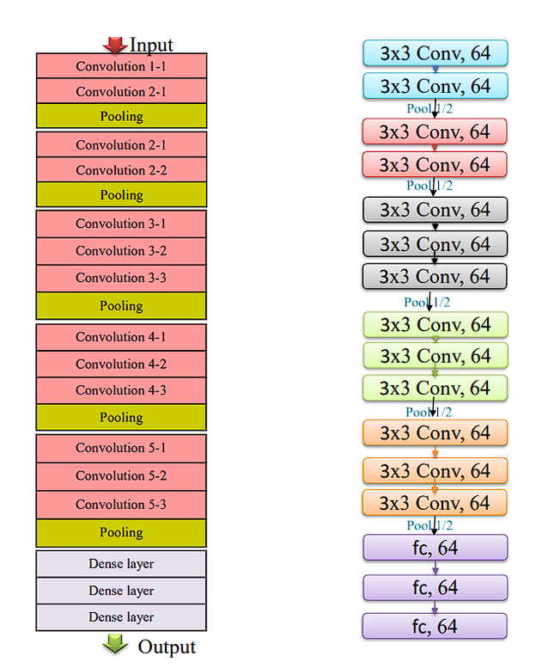

Fig. 2.1 Block Diagram of VGG16

2.2.2 ResNet50
This is a deep convolutional neural network that overcomes the vanishing gradient in deep learning. Here, residual connections are introduced in such a way that it bypasses one or more layers while training. Instead of learning directly the mappings, residuals, which is a result of input minus output, and makes easier to optimize for deeper networks.
The architecture of ResNet50 is detailed in:
1. Convolutional Layers: Extract feature from the input image; the first layer applies 7x7 convolution followed by max-pooling downsampling.
2. Residual Blocks: Consist of two or three convolutional layers with skip connections that add the input directly to the output to enhance the gradient flow.
3. Batch Normalization & ReLU: Used after every convolution for normalization and for non-linearity.
4. Bottle-neck Architecture: A1x1, 3x3, and 1x1 convolutional structure to support efficiency.
5. Global Average Pooling: Transforms feature maps into a single feature vector just before classification.

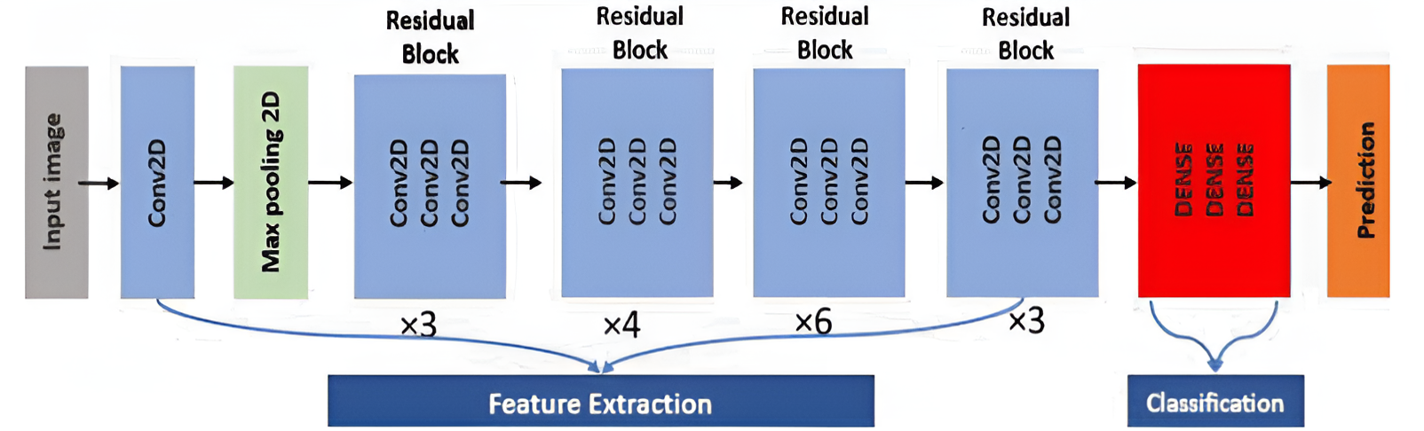

Fig. 2.2 Block Diagram of ResNet50

2.2.3 EfficientNetV2B0
Google AI researchers, proposed EfficientNet in 2019. A paper "EfficientNet: Rethinking Model Scaling for Convolutional Neural Networks" by Mingxing Tan and Quoc V. Le introduced it. The model scaling presented here by EfficientNet remained the main innovation based on compound scaling in order to gain the proper balance between depth, width, and resolution of the network, and as a result, is efficient in terms of both accuracy and computational cost.
The efficient parameters in the model make it possible to reach state-of-the-art accuracy; at the same time, they are rather more computationally efficient than architectures like ResNet and Inception. Thus, models of EfficientNet gained extensive usage in the majority of computer vision tasks, such as image classification, object detection, and medical image analysis.
This EfficientNet family ranges from B0 to B7 and comes with Larger scale, increased complexity and parameter sizes for better performance or task-specific. These factors set scales, or scaling coefficients (B0 to B7), dictate what are essentially model characteristics, with B0 as smallest and B7 as biggest. The size index represents a compromise between model-size and performance.
The use is a balanced choice that entails efficiency while keeping effectiveness. In terms of image classification, the Efficientnet-B0 applies compound scaling. It optimizes the trade-offs with respect to complexity and efficiency. SE blocks boost the process of recalibration for good performance. Competitive accuracy and minimal demand for computations make Efficientnet-B0 a standard baseline in the vision community, offering a reference on how to balance the delicate equilibrium between efficiency and effectiveness. Model Size and Accuracy Relationship in Resource-Constrained Scenarios.

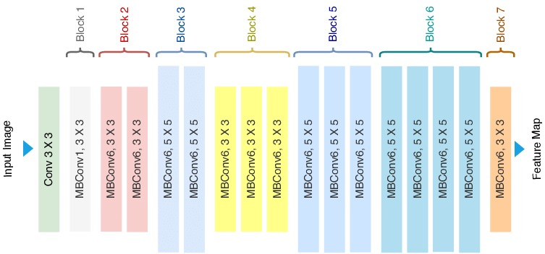

Fig. 2.3 Block Diagram of EfficientNet

3.Methodology
3.1 Data Preparation
The dataset used in the project is the “Knee Osteoarthritis Severity Grading Dataset”, obtained from the osteoarthritis initiative [11] (OAI), There are 8260 images in the dataset and organized with their respective class. To enhance the performance of the model, X-ray images need to be preprocessed. Preprocessing is done by reducing the quantum noise by the median filter, adjusting the contrast of the images by histogram equalization and finally using unsharp masking to sharpen the details like edges.
For multi-class classification in KOA, class imbalance and limited data are two problems so we augmented the preprocessed data to balance data used for training the model for feature extraction in which each class contains 2000 (1600 for training and 400 for validation).
3.2 Proposed Model
The augmented images are fed into a pretrained model ResNet, a CNN model to extract features from the images. The Resnet model come with weights that have already learned to identify various features in images by training on a large dataset like ImageNet.
The fully connected layers at the end of the network are discarded, which are specific to the classification task of the original dataset (e.g., ImageNet). The remaining convolutional layers are used to extract feature maps from the input images. These layers capture various hierarchical features, from simple edges to complex patterns.
The extracted features from ResNet will be fed into the Convolutional Block Attention Module (CBAM) to enhance their representation. CBAM will apply two sequential attention mechanisms: channel attention and spatial attention. The channel attention module will focus on identifying the most important feature channels by analyzing both average and max-pooled features and combining them. The spatial attention module will then highlight the critical spatial regions within these feature maps by combining average and max-pooled features across the channel dimension and passing them through a convolutional layer. This dual attention mechanism ensures that the most informative features are emphasized and less relevant ones are suppressed, leading to a refined and enhanced feature representation that can significantly improve the classification performance of the subsequent Support Vector Machine (SVM) model.
The refined features obtained from CBAM will be fed into a Support Vector Machine (SVM) for classification. The SVM model will be trained to classify the images into five distinct classes, leveraging the refined features for improved accuracy. SVMs excel at finding the optimal hyperplane that maximizes the margin between different classes, ensuring robust and precise decision boundaries. This combination of enhanced feature extraction and powerful classification boosts the overall performance of the model, leading to highly accurate and reliable image classification.
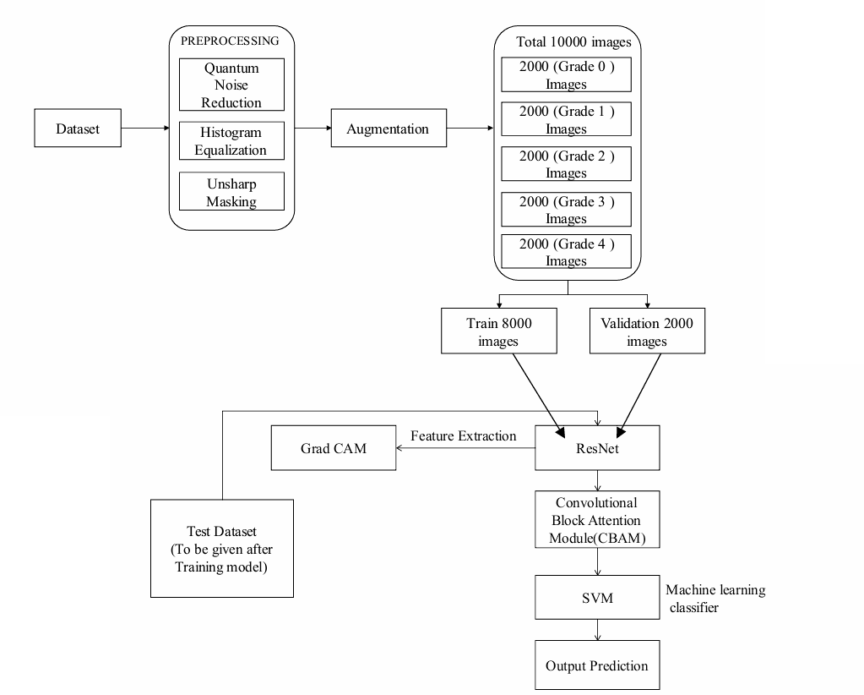
To interpret and visualize the model's decision-making process, Gradient-weighted Class Activation Mapping (Grad-CAM) will be employed. Grad-CAM generates heatmaps that highlight the important regions in the images contributing to the model's predictions. The process involves computing the gradient of the class score with respect to the feature maps, obtaining weights that signify the importance of each feature map, and generating a heatmap by multiplying these weights with the corresponding feature maps. This heatmap, superimposed on the original image, visually represents the areas of focus. Grad-CAM provides valuable insights into the model's workings, enhancing interpretability.

Fig. 3.1 Proposed Framework

3.3 Data Preprocessing
X-rays images contain noise or low contrast and also the edges will be blur. So, to get the best results the preprocessing will done. In this project we used 3 types of preprocessing.
3.3.1 Quantum Noise Reduction
X-ray images mainly have quantum noise so we used quantum noise reduction to remove it which will enhance image quality and feature detection. Median filters used to remove quantum noise.Median filter will replace the value of the pixel by taking the median of the surrounding pixels in the mask. The mathematical representation of median filter:
${ I}^{'}\left(X\right)=median\{I\left(y\right):y∊ N(x)\}$ (4.1)
Noise reduction technique that effectively replaces each pixel value with the median value of neighboring pixels is called the median filter.
3.3.2 Histogram Equalization
In this project we used histogram equalization to improve the visibility of important features by enhancing contrast which helps in distinguish between details like Bone deformities, osteophyte formation etc, Histogram equalization distributes the pixel intensities evenly across the range in an image. Mathematically, it can be represented as:
$T(i)=round\left.\left(\frac{(L-1)}{n}\sum_{j=0}^{i}{h(j)}\right.\right)$ (4.2)
Histogram equalization in KOA X-ray images enhanced the contrast, improved feature visibility for both manual detection and automated models.
3.3.3 Unsharp Masking
This technique is used to enhance edges and fine details which helps in distinguish the details like joint space narrowing, subchondral bone sclerosis. To get the output of the unsharp masking, the blurred image will be subtracted from the original image. The mathematical representation of unsharp masking:
$I' = I+α(I -G(I))$ (4.3)

By improving the visibility of these details like joint, unsharp masking aids both human radiologists and machine learning models in making more accurate diagnoses of osteoarthritis.
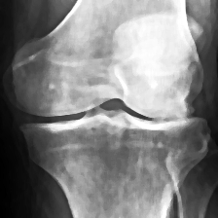
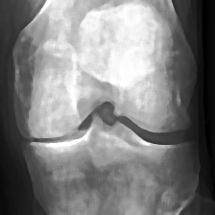
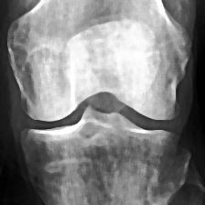
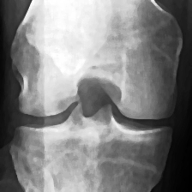
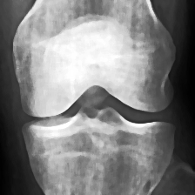
Grade 0 Grade 1 Grade 2 Grade 3 Grade 4
Fig. 3.2 Preprocessed X-ray Images

3.4 Data Augmentation:
One of the main problems while doing multi class classification in KOA is data set class imbalance and also the dataset being limited. To address these problems, we did augmentation to ensure all classes have same amount of data for training and validation. The applied transformations during data augmentation include image resizing, rotation, shearing, zooming, and horizontal flipping, collectively contributing to the creation of a more robust and diverse training dataset.
Table 3-1 Augmented Data Set
KL grade | Test | Train | Validation | Total
0 | 658 | 1600 | 400 | 2658
1 | 816 | 1600 | 400 | 2816
2 | 760 | 1600 | 400 | 2760
3 | 860 | 1600 | 400 | 2860
4 | 923 | 1600 | 400 | 2923

3.5 Software
3.5.1 Visual Studio Code
Visual Studio Code, an initiative of Microsoft, is a light but powerful code editor that is used on multiple platforms; its markets include Windows, macOS, and Linux. Its versatility and performance make it one of the best tools used by developers from different parts of the world. Though light in weight, VS Code has all the specific features of an integrated environment, and that allows developers to write, test, or debug programs easily. With wide language support that includes Python, JavaScript, C++, and many other programming languages, it is perfectly apt for a wide array of developmental work-from software, web design, and machine learning projects.
Among the most important strengths of VS Code is extensibility. Visual Studio Code Marketplace comes with thousands of extensions and can be added in quick succession for enhancing one's capabilities of the editor. Such extensions could be third-party support for new programming languages, frameworks, or other tools. For example, while working on a machine learning project or on any data science project, extensions like "Python" and "Jupyter" are convenient. These extensions ensure an easy ride in the development, testing, and debugging of any machine learning model, such as an image classification model.
The debugging capabilities of VS Code are also very strong. It comes with a feature set for in-built breakpoints, stepping through code, and live monitoring of variables. Version control integration on top of Git can be provided for simplification of workflow by allowing users to do repository management, track their changes, and collaborate on code right from their editor. Another add-in like the built-in terminal helps execute command-line tasks, which are really useful for running scripts and managing packages right within the development environment.
One of the strengths of VS Code is that it allows for customization. Developers can make the editor look the way they want through a large selection of themes, personalized keyboard shortcuts, and customized workspace settings. This flexibility enables an experience better suited to the individual's or user's preference. What's more is that the Live Share extension enables live sharing. Provided that team members have installed the latest edition of the Live Share extension, they ought to be able to work on the same codebase from a remote location easily.
3.5.2 Jupyter notebook
Visual Studio Code is considered to be very great support for Jupyter Notebooks since it makes this tool come alive with an extension-its Jupyter which developers and data scientists use to support their data analysis, machine learning, as well as doing research projects. With the Jupyter extension, VS Code allows users to create, edit, and run Jupyter Notebooks directly within the VS Code environment, meaning no need to switch between different tools. By making notebook support available in VS Code, it brings a unified interface onto the screen which combines the interactive nature of Jupyter with the full capabilities of a traditional code editor.
Another significant aspect of Jupyter usage in VS Code is that it offers an interactive coding environment. Code cells can be run one at a time and their results seen inline, step by step, just like the original interface for the Jupyter Notebook. But when this functionality is brought to VS Code, it brings numerous benefits, such as IntelliSense or "smart" autocompletion, debugging tools, and better code formatting, which really make the workflow a lot more streamlined for coding and for interactivity in notebooks.
Other important features of the Jupyter extension in VS Code include the Variable Explorer and Data Viewer. This is mainly because it makes it possible to inspect variables, datasets, and other data structures in more intuitive manners. In fact, when dealing with big-size datasets or complicated arrays, the Data Viewer representation usually comes out to be tabular and more intuitive to deal with. That makes VS Code an excellent environment for data science tasks wherein the exploration as well as visualization of data are considered critical.
VS Code also provides kernel management for Jupyter Notebooks. It can have several kernels, so this would work with different languages like Python and R, and others. The user may easily switch over from one kernel to another, changing the environment, so all dependencies would be in place. Moreover, upon installation of the Python extension into VS Code, it will detect and integrate with multiple environments of Python, such as Conda or virtual environments, and let you be easily able to work with Jupyter Notebooks and the desired libraries. Thus, it can easily ensure usage with the right environment for the notebook, increasing efficiency and reproducibility from one project to another.

4.Results and Discussion
4.1 Data Set
The dataset used in the project is “Knee Osteoarthritis Severity Grading Dataset” [11]. This dataset contains knee X-ray data for both knee joint detection and knee KL grading. The dataset is organized from OAI. The data set consists of 8260 X-ray images divided into 3 folders train, test, val which further divided into 5 classes in each folder.
Table 4-1 Data Set Information
KL grade | Test | Train | Validation | Total
0 | 639 | 2286 | 328 | 3253
1 | 296 | 1046 | 153 | 1495
2 | 447 | 1516 | 212 | 2175
3 | 223 | 757 | 106 | 1086
4 | 51 | 173 | 27 | 251

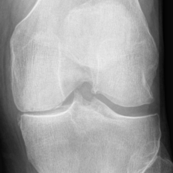
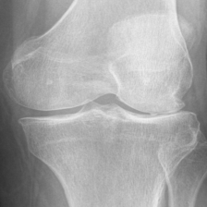
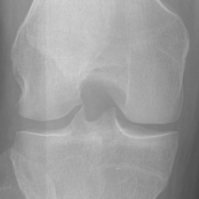
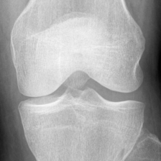
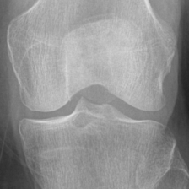

Grade 0 Grade 1 Grade 2 Grade 3 Grade 4
Fig. 4.1 Normal X-ray Images
4.2 Evaluating state of the art models
VGG16:
The results obtained after training and testing VGG16 model with the augmented dataset.
Accuracy | Precision | Recall | F1-Score
0.8616 | 0.9012 | 0.8231 | 0.8616
Table 4-2 Performance metrics

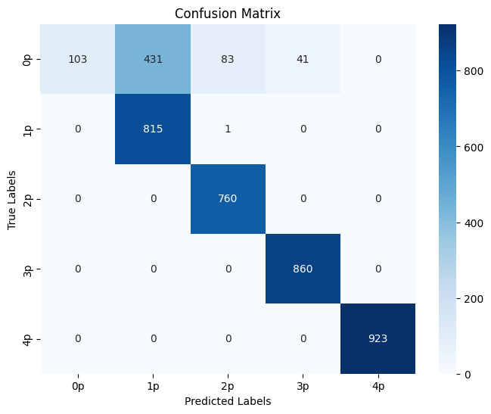

Fig. 4.2 Confusion matrix for KL grade prediction using VGG16
ResNet50:
The results obtained after training and testing ResNet50 model with the augmented dataset.
Table 4-3 Performance metrics
Accuracy | Precision | Recall | F1-Score
0.8382 | 0.9087 | 0.7822 | 0.8382

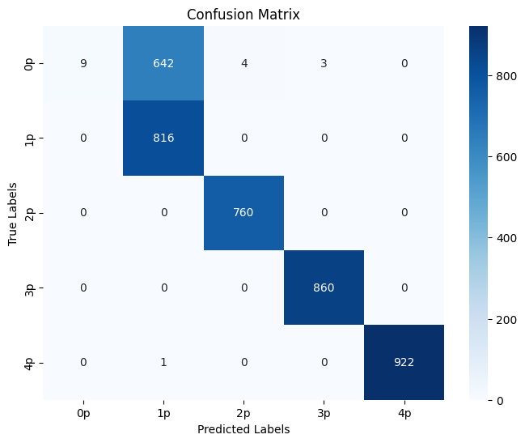

Fig. 4.3 Confusion matrix for KL grade prediction using ResNet50
EfficientNetV2B0:
The results obtained after training and testing EfficientNetV2B0 model with the augmented dataset.
Table 4-4 Performance metrics
Accuracy | Precision | Recall | F1-Score
0.8382 | 0.9087 | 0.7822 | 0.8382

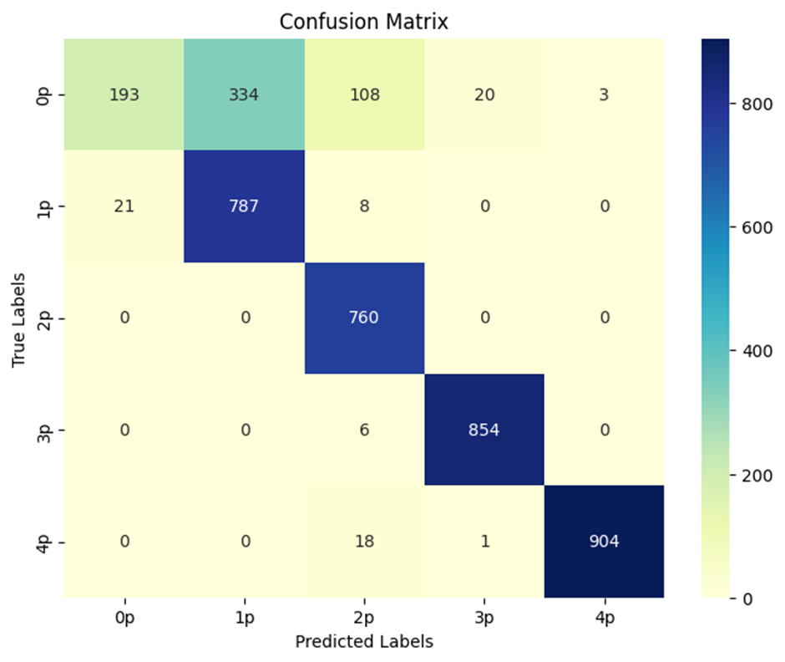

Fig. 4.4 Confusion matrix for KL grade prediction using EfficientNetV2B0

5. Conclusion
In this project the proposed model used ResNet as the feature extraction in the classification of knee osteoarthritis X-ray images and adding CBAM for increasing the representation ability of the features, SVM was considered as the classifier to classify the given class with five classes of stage for KOA accurately. The class imbalance and reduced availability of data simultaneously have been well managed in the proposed work using data augmentation methods to make the training process possible by a balanced dataset. Quantum noise reduction, histogram equalization, and unsharp masking techniques were applied that improved visibility in the image to a large extent. This enhanced the accuracy of the classification task.
References
[1] E. Bahar, D. Shamarina, Y. Sergerie, and P. Mukherjee, “Descriptive Overview of Pertussis Epidemiology Among Older Adults in Europe During 2010–2020,” Infectious Diseases and Therapy, vol. 11, no. 5, pp. 1821–1838, Jul. 2022.
[2] E. A. Fallon, “Prevalence of Diagnosed Arthritis — United States, 2019–2021,” MMWR. Morbidity and Mortality Weekly Report, vol. 72, no. 41, Oct. 2023.
[3] L. Jiang et al., “Body mass index and susceptibility to knee osteoarthritis: A systematic review and meta-analysis,” Joint Bone Spine, vol. 79, no. 3, pp. 291–297, May 2012.
[4] S. Aslan, "Automatic Detection of Knee Osteoarthritis Disease with the Developed CNN, NCA and SVM Based Hybrid Model," in Traitement du Signal, vol. 40, no. 1, pp. 317-326, Feb. 2023.
[5] A. R. Patil and S. salunkhe, “Classification and Risk Estimation of Osteoarthritis Using Deep Learning Methods,” Measurement: Sensors, p. 101279, Jul. 2024.
[6] D. W. Lee, D. S. Song, H.-S. Han, and D. H. Ro, “Accurate, automated classification of radiographic knee osteoarthritis severity using a novel method of deep learning: Plug-in modules,” Knee Surgery and Related Research, vol. 36, no. 1, Aug. 2024.
[7] R. K. Jain, P. K. Sharma, S. Gaj, A. Sur, and P. Ghosh, "Knee osteoarthritis severity prediction using an attentive multi-scale deep convolutional neural network," Multimedia Tools and Applications, vol. 83, pp. 6925–6942, June 2023.
[8] P. Chen, L. Gao, X. Shi, K. Allen, and L. Yang, "Fully automatic knee osteoarthritis severity grading using deep neural networks with a novel ordinal loss," Computerized Medical Imaging and Graphics, vol. 75, pp. 84-92, June 2019.
[9] K. Fatema et al., “Development of an automated optimal distance feature-based decision system for diagnosing knee osteoarthritis using segmented X-ray images,” Heliyon, vol. 9, no. 11, p. e21703, Nov. 2023.
[10] M. U. Farooq, Z. Ullah, A. Khan, and Jeonghwan Gwak, “DC-AAE: Dual channel adversarial autoencoder with multitask learning for KL-grade classification in knee radiographs,” Computers in Biology and Medicine, vol. 167, pp. 107570–107570, Oct. 2023.
[11] Y. X. Teoh, A. Othmani, K. W. Lai, and S. L. Goh, "Stratifying knee osteoarthritis features through multitask deep hybrid learning: Data from the osteoarthritis initiative," Computer Methods and Programs in Biomedicine, vol. 242, p. 107807, Sep. 2023.
[12] A. S. C. Bose, C. Srinivasan, and S. I. Joy, "Optimized feature selection for enhanced accuracy in knee osteoarthritis detection and severity classification with machine learning," Biomedical Signal Processing and Control, vol. 97, 106670, Aug. 2024.

[13] Y. Wang, Z. Bi, Y. Xie, T. Wu, X. Zeng, S. Chen, and D. Zhou, "Learning From Highly Confident Samples for Automatic Knee Osteoarthritis Severity Assessment: Data From the Osteoarthritis Initiative," IEEE Journal of Biomedical and Health Informatics, vol. 26, no. 3, pp. 1239-1250, Mar. 2022.
[14] Chen, Pingjun (2018), “Knee Osteoarthritis Severity Grading Dataset”, Mendeley Data, V1. [Online]. Available: https://tinyurl.com/4h7pwaaa. [Accessed Sept. 12, 2024].
‌

